MAIDEN BRADLEY WITH YARNFIELD PARISH COUNCIL

Action Plan 2015/2016

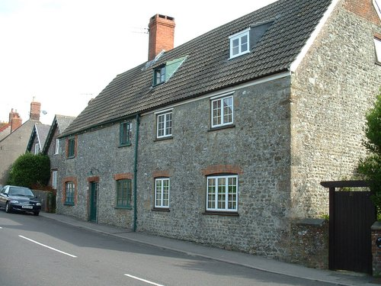

Document prepared by: The Clerk, February 2015
Review date: February 2016

CONTENTS

Introduction 2

Context 2

The planning cycle 3

What is a Parish Council? 4

What can we do? 4

Powers and Duties 4

Accountability 4

What do we do? 5

What we achieved in the last year 5

What do we want to do next? 6

Issues and Actions 7

Review and performance 8

Comments 8
Introduction

Welcome to the Maiden Bradley with Yarnfield Parish Council. This is our Plan – it sets out what we are going to do over a rolling year period of two years. The Plan takes into account the issues facing us and our ability to respond with the resources available. It makes clear there will be choices, and how the Council will decide which to prioritise.

The Plan has been prepared and approved by your parish councillors. It is essentially a planning tool to assist us with the practical decisions we have to take when we meet monthly, supported by a review process that helps us, and you, look back on our performance. By publishing our Action Plan we can help those that live, work or visit the Parish see what we are doing on their behalf.

Context

This is our first Action Plan, prepared at a time of austerity across society when all organisations that provide services to the community, be they public, private or voluntary are facing cost pressures and resource restrictions. The emphasis is on value for money, efficiencies, collaboration and accepting that some things just will not get done. Through a planning process though, we can have a shared vision and direction, protect what is important and consider new ways of getting things done.
Although not new, encouraging others to help themselves and not to rely on things being done for them is as important as ever. The aspiration for Wiltshire has been set out elsewhere as ‘building stronger and more resilient communities’. That means communities that can help themselves, that have the networks and resources to find local solutions to local problems, and have the means to ensure that wherever possible those that do need services can access them at a time and in a way that is most suitable.
Maiden Bradley with Yarnfield Parish Council, as the first tier of local government, is uniquely situated to provide the forum for understanding and supporting the needs of this community. It provides advocacy on behalf of its residents, uses linkages to other organisations to bring in services, or directly procures them itself. Liaison with Wiltshire Council happens at all levels, and there are linkages to health and social care as well. Day-to-day, the Council will seek solutions for the community, looking for skills and volunteers to make improvements to our surroundings or bringing particular neighbourhood issues to local attention to promote a better quality of life for all.
Above all, your Parish Council is here to help, support and encourage. This Plan tells you how.
The Planning Cycle
Planning (and performance) is a continuous process of gathering and assessing information, formulating actions, doing them, and then reviewing performance and gathering again.
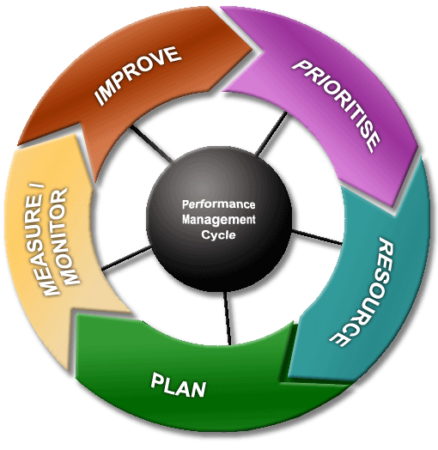

Of course at key stages one has to pause and reflect, and consider how the plan is evolving – and not just once per year, as the plan is relevant to every significant decision made.
Once specific actions are agreed to deliver this Plan, they are entered on the Actions Register, which is monitored at every meeting of the Council.
Linkages
This Plan is linked very closely to the allocation of resources – mostly financial, but people’s time and energy too. Our finance is almost entirely derived from the Council Tax system, which follows the financial year April to March. Our precept, or ‘demand’, placed upon the Council Tax system has to be declared every January, in order that Wiltshire Council can calculate the overall tax collection sums for each eligible household and produce the billing required.
Key dates
Therefore, this Plan will be drafted from November in each year, allowing it to evolve as the budget is also prepared, for final precept calculations in January. The Plan cycle will run from April to March, to match the funding available, and will be formally reviewed in May and November to assess achievements in the previous cycle, and progress in the current one.

July November January March May
look back, look forward improve, prioritise set precept completion review, resource

MEASURE / MONITOR
What is a parish council?
There are two sorts of parishes whose boundaries do not always coincide:
- the Ecclesiastical Parishes centred on an Anglican church with a parochial church council and,
- the Civil Parishes, which are part of local administration, having a parish (or town) council.
A civil parish is an independent local democratic unit for villages, smaller towns, and suburbs of urban areas. Each parish has a Parish (or Town) Meeting consisting of all its local government electors and most (where the electorate exceeds 200) have a Parish or Town Council. Over 13 million people live in such parishes, with just over 331 in the parish of Maiden Bradley with Yarnfield.
The parish council is a small local authority. Its councillors are elected for four years at a time in the same way as for other councils. Bye-elections may be held to fill vacancies occurring between elections, or members may be co-opted onto the Council if no election is called. The council is the corporation of its parish in the Wiltshire area. It covers the village of Maiden Bradley and Yarnfield. In May each year the councillors choose a chairperson from amongst their number. In the Maiden Bradley Parish, there are 7 councillors who make up the Parish Council, which employs a part-time clerk to manage administration.

What can we do?
Powers and Duties
Parish councils have a number of formal powers, set out in a wide range of legislation. A duty is something that a council must do: a power is something that it may do, if it so decides. A parish council cannot do anything that is not permitted in law.
Parish Councils in Wiltshire have lately become more significant, as District Councils have been removed and because the unitary authority could then seem more remote. The parish councillors know the villages and can now (and increasingly often do) represent their views directly to other authorities like the Unitary Council at its Area Boards, Health Authorities, Police and Fire Authorities. They are entitled to be consulted on planning applications, which include work to listed buildings and on proposals in conservation areas, and are often consulted on such things as schools and roads. They put forward the parish’s case at public inquiries. Recent moves from Government toward greater 'localism' are set to increase the role of Parish Councils even further, especially in the field of development control and planning. There is now the power to create a Neighbourhood Plan which allows local people to get the right development for their community but the plans must still meet the needs of the wider area.

Accountability
You elect its members every four years - the next time will be May 2017 - and you are entitled to go to the annual parish meeting (in May) to air your views appropriately. You can also go to every meeting of the Parish Council and meet the Council members, listen to their business and participate in the time especially set aside for that purpose at the start. The accounts are strictly audited every year and published.
You can find out more about what we do, how we do it, and our meetings on the parish website at http://www.southwilts-communityweb.com/site/maidenbradley-Parish-Council/
What do we do?
The Parish Council provides a number of direct services to the community, and acts as custodian to a number of assets held in the 'public name'.
The assets held in the public name are a Park Bench, two Notice Boards, the Memorial Trough, Street Furniture, Gates and Fences on the Knapp and Fencing at Play Area, the Foxes’ head (Memorial), Playground Equipment comprising 2 Polynesia Hippo Springers, Three Seat Anti-wrap swing, Action Pacl TOBA, Royale all Steel Bench, Goal Force Action Sports Wall and the surface beneath the equipment in the toddler play area. Office Equipment comprising of Projector, A3 Printer/Cables, Dell Laptop, an External Hard drive, Ergo-Q Laptop Stand and a Computer Chair. The Council is responsible for maintenance, repairs and insurance for these items and facilities.
Although Wiltshire Council is the Planning Authority, the Parish Council is consulted on each planning application made in the parish. Councillors consider planning applications at their meetings, and inform Wiltshire Council of their views.
At each meeting of the Council, reports from a variety of village organisations are received, and Councillors seek to provide support where necessary or requested in order that local groups can continue to thrive. Reports include observations from the Village Hall Committee (consisting of both Councillors and volunteer members of the Public). Each meeting considers issues for our communities such as planning (for example, housing or tree felling) speeding and volume of traffic, inappropriate use of rights of way, crime and community safety, facilities for young people, or items of maintenance in the 'public realm' that need reporting to appropriate authorities. The Council can act as advocate for residents, a conduit for communicating information, and will liaise with appropriate departments of other public authorities to ensure that views, comments and necessary actions are dealt with.
What we achieved in the last year
Between April 2014 and March 2015, we have achieved a wide range of improvements, both to the way we work, and to the community we serve:
Adopted new rules and procedures based on a national model from the National Association of local Councils which includes public participation for part of our meetings;
Established policy statements on Equal Opportunities, Dignity at Work/Bullying and Harassment Policy, a Community Engagement Statement of Internet aims and objectives, together with a revised complaints policy, Lone Workers policy and a General Reserves policy.
Debated a range of traffic, transport, and road safety issues leading to representation at the Warminster Area Board, Community Traffic Action Group and Neighbourhood Tasking Group Meetings
Considered 7 planning applications, most of which were supported by this Council
What do we want to do next?
The Parish Council has worked through the parish plan working group’s findings and added a few issues to the Action Plan.
The table below sets out the Action Plan adopted by the Council and arranged over the next two years:
Ser | Issue | Action | Lead Partners | Resource Implications | Timescale
Long-term Overview
1 | Maintain impetus of Action Plan | Formal and regular overview by Parish Council | MBPC | Nil | At MBPC discretion
2 | Maintain relevance of Parish Plan | Annual review by MBPC | MBPC | Nil | At MBPC discretion
Facilities and Services
3 | Providing facilities for children, young people and families | Review the recreational area facilities and capture ideas for future consideration | MBPC,  A working group | Small consultation expenses | Complete by end 2015
Crime and Community Safety
4 | Maintaining current satisfactory situation. | Maintain current Neighbourhood Watch organisation.  Encourage reporting of fly tipping to Wiltshire Council.  Maintain periodic ‘litter pick’. | MBPC,  Volunteer  All residents | Small. Some assistance available from Wiltshire Council for ‘litter pick’. | Regular and frequent monitoring
Culture, Leisure and Recreation
5 | Need for new ideas, particularly for children and young people | Capture ideas for future consideration | MBPC,  Village Hall Committee | Small consultation expenses | Complete by end 2015
Local Economy and Tourism
6 | Assisting the local economy, including encouraging tourism | Consider better marketing of the church, countryside, walks, B&Bs, etc | MBPC,  A working group | Will evolve out of planning actions | Continuing
7 | Assisting economic growth | Advertising in the Parish News. Working with the Village Shop/Village Hall | MBPC, PCC, Editor, Village Shop/ Village Hall Committee | None | By end 2015
Education and Communications
8 | Improve communication of Parish Council activities | Monthly Parish News  Facebook Page  Noticeboards | MBPC | £200 | Continuing
Environment and Countryside
9 | Maintain support for conservation and restoration in villages and countryside | Consider forming special interest group.  Consider preparation of a Village/Parish Design Statement | MBPC  Farmers  A working group | <£100  >£500 | By 2016
10 | Improve knowledge and understanding of Rights of Way, their use and accessibility | Advertise Rights of Way Standard  Request feedback on condition of rights of ways walked by parishioners | MBPC  Farmers  House owners | None | By 2016
11 | Possible Listing of Fountain and the mural in the village hall | Parish Council to work with the Village Hall Committee and look at listing the fountain Memorial | MBPC, Village Hall Committee | None | By 2016
Health and Social Care
12 | Improve support to older people | Consider forming Working Group to examine: mutual support by/for older people, provision of further outside support. | MBPC  Working group?  Wilts Good Neighbour Service Grant | Grant £100.00 | By end 2015
Housing, Development and the Built Environment
13 | Taking forward local preferences when considering local planning applications. | Village Design Statement/neighbourhood Plan to be discussed | MBPC | Nil | Continuing
14 | Wiltshire Council’s respect for local views in determining housing strategy allocations and individual planning applications. | Awareness of the Parish Plan  Housing Survey Kept updated | MBPC | Nil | Continuing
Transport and Traffic
15 | HGV use of B3092 | Monitor and hasten implementation of weight restrictions on B3092 | MBPC | Nil | Continuing
Crime and Community Safety
16 | Neighbourhood Watch | Volunteer to action this project | MBPC  Parish News | Volunteer to receive support and be able to use the parish news & Facebook as a reporting medium | Continuing

